# Objective

You will use a recursive method to create a structure known as **Sierpinski’s Triangle**, also sometimes called Sierpinski’s Gasket.

## Topics: recursion, Sierpinski

# Instructions

You will write a method with the following signature:

void **sierpinski**(float ax, float ay, float bx, float by, float cx, float cy)

The **sierpinski()** method will draw a triangle with the top vertex at (ax, ay), the bottom-right vertex at (bx, by) and the bottom-left vertex at (cx, cy). Then, as long as the side length exceeds a minimum value (this is your *base case* for recursion), you will:

1. Calculate the midpoint of side $\overline{\overline{ab}}$
2. Calculate the midpoint of side $\overline{bc}$
3. Calculate the midpoint of side $\overline{ca}$
4. Call **sierpinski()** three times, to create three triangles anchored on the vertices of the current triangle, like so:

# Examples

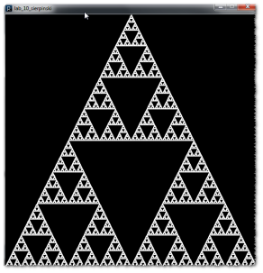

1

2

3

midpoint of $\overline{ca}$

midpoint of $\overline{\overline{bc}}$

midpoint of $\overline{\overline{ab}}$

a

b

c